**Temperature and humidity sensor**

1. Wiring diagram

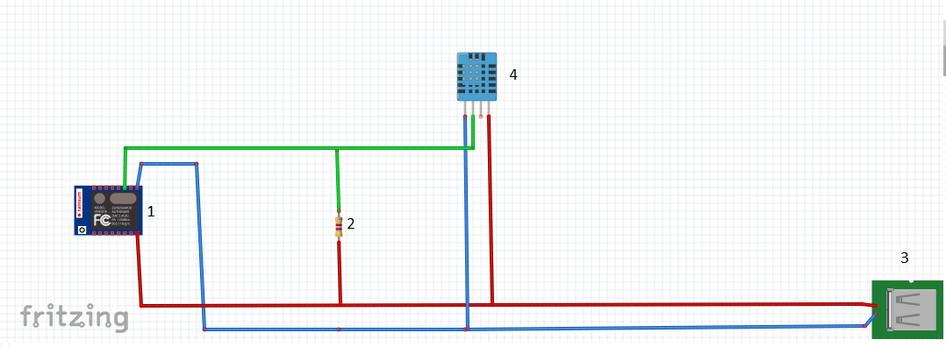

1. The necessary elements

1. ESP 12e nodemcu v3

2. Resistor 4.7kΩ

3. USB (5V)

4. DHT11